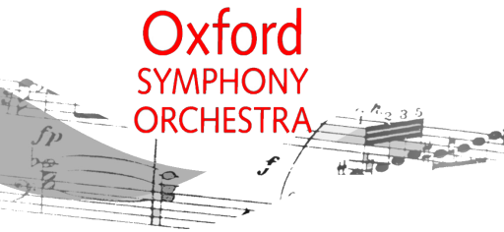
Charity Gift Aid Declaration – multiple donation
Boost your donation by 25p of Gift Aid for every £1 you donate
Gift Aid is reclaimed by the charity from the tax you pay for the current tax year. Your address is needed to identify you as a current UK taxpayer.
In order to Gift Aid your donation you must tick the box below:
□ | I want to Gift Aid my donations of £ ______________ and any donations I make in the future or have made in the past 4 years to the Oxford Symphony Orchestra, registered charity 284339.
I am a UK taxpayer and understand that if I pay less Income Tax and/or Capital Gains Tax than the amount of Gift Aid claimed on all my donations in that tax year it is my responsibility to pay any difference.
My Details
Title ______________ First name or initial(s) ___________________________________
Surname ____________________________________________________________________
Full Home address ____________________________________________________________
________________________________________________________________
Postcode _____________________
Date _________________________
Please notify the Treasurer (email osotreasurer@gmail.com) if you:
- want to cancel this declaration
- change your name or home address
- no longer pay sufficient tax on your income and/or capital gains
If you pay Income Tax at the higher or additional rate and want to receive the additional tax relief due to you, you must include all your Gift Aid donations on your Self-Assessment tax return or ask HM Revenue and Customs to adjust your tax code.

